STUDY PROJECT TITLE
E-Commerce Consumers Spending Pattern Analysis

Team Details
- K. SRI KEDHARNATH (23EG110E04)
- M. G RU SHNES WAR ( 23EG110E 52)
- B. REVANTH ROHAN NAIK (23EG110E56)
Project Supervisor
Name: Dr. Biksham V
Designation: Assistant Professor



Department of Data Science 1

Introduction
E-commerce platforms generate large amounts of transaction data that provide valuable insights into consumer purchasing behavior. Understanding these spending patterns helps businesses improve marketing strategies, pricing decisions, and product management.
This project analyzes an e-commerce dataset using data visualization techniques in Tableau to identify patterns, trends, and relationships in consumer spending behavior.
Department of Data Science 2


Problem Statement
Online retail businesses collect large amounts of sales data, but extracting meaningful insights from this data can be challenging.
Understanding which products sell the most, how discounts affect profits, and how customer segments contribute to sales is important for business decision making.
This project aims to analyze consumer spending patterns using data visualization techniques.

Department of Data Science 3


Abstract
This project analyzes consumer spending behavior using an e- commerce dataset obtained from Kaggle.
The study focuses on identifying sales trends, top selling
products, category performance, discount impact on profit, and customer segment behavior.
Using Tableau, several visualizations and an interactive dashboard were created to transform raw data into meaningful insights that support better business decisions.

Department of Data Science 4


Objectives
- To analyze consumer spending patterns in an e-
commerce dataset.
- To identify the top selling products based on sales.
- To examine sales trends over time.
- To analyze the relationship between discount and profit.
- To study the contribution of different customer segments to overall sales.
- To present insights through interactive Tableau visualizations.

Department of Data Science 5

Collect Data

Methodology


The e-commerce dataset was obtained from Kaggle and contains transaction-level information about product sales, customers, and order details.

Prepare Data
The dataset was imported into Tableau from a CSV file.
Data fields were checked to ensure correct data types and structure
for analysis.

Data Understanding
Important attributes such as Sales, Profit, Discount, Category, Sub- Category, Segment, and Order Date were identified for analysis.
Department of Data Science 6


Methodology

Dashboard Development
Combine all visualizations such as bar charts, line charts, heat maps, scatter plots, stacked bar charts, and box plots into a single Tableau dashboard to provide an integrated view of the analysis. Interactive Analysis
Use Tableau filters and interactive features to explore data dynamically. This allows users to analyze sales by category, customer segment, region, and other attributes.

Insight Generation
Interpret the visualizations to identify important patterns, trends, and relationships within the dataset. These insights help understand consumer spending behavior, product performance, and profitability patterns.
Department of Data Science 7


Technology

CSV Dataset
Used to store the car sales data.

Tableau Desktop / Tableau Public
Used for creating visualizations and interactive dashboards.

Data Visualization Techniques
Used to identify patterns, trends, and relationships in the dataset.

Department of Data Science 8


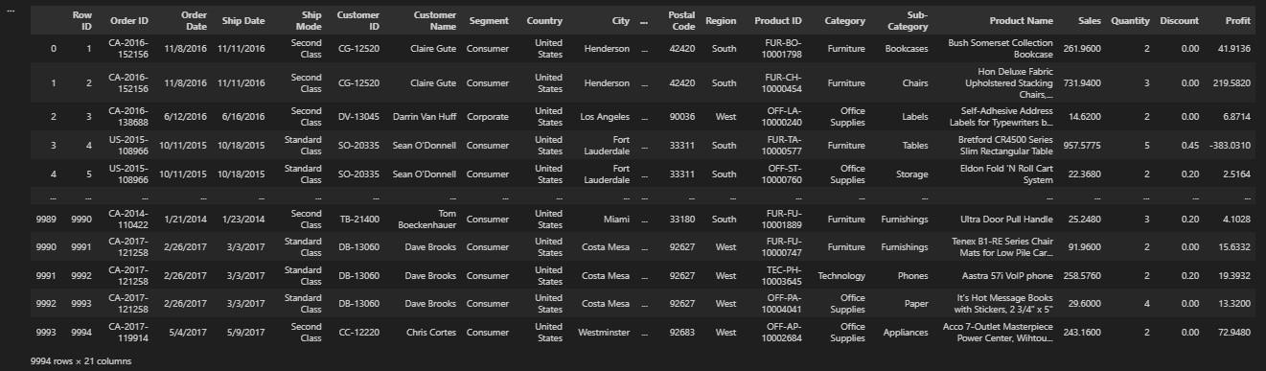
DataSet

Department of Data Science 9


Steps

Step 1: Horizontal Bar Chart

Displays the top selling products based on total sales. Helps identify which products generate the highest revenue.

Columns: SUM(Sales)
Rows: Product Name

Department of Data Science 10

/| Tableau Pübllc - Book1
ȚFile ¿Data Worksheet Dashğoard Story Anałysiš Map Format Server Window .Herp,

Data AFIdl 1l*S
.@ ecommerce dátä...
* I?aj2ea

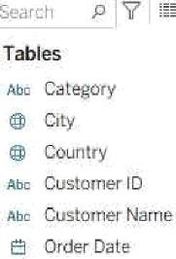
Aü , Order,ID @ PasŁăl.Eodé roe Product ID
sõo. Product,Narrie.
/tbc Reğión
4 Rowl”D áçc S.^8rñent E] Ship Date ãü . Shiș'Mode
@ State
Abc Sub-TaŁegcry

Disčòufit

4 Quantity
Ã Sales


Marks

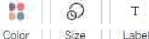
Õ Automatic

M ( S e e a

Top Selling Products

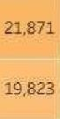
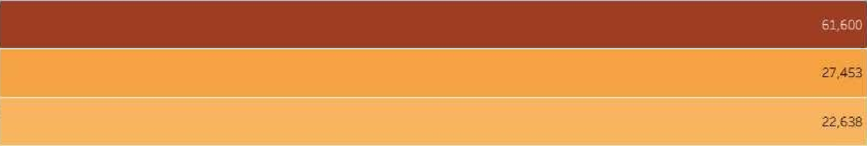
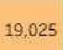
Prsduct I\lame -
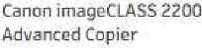
_ fiellowes PB500 Electric Púnch Plastic Comb Bindi..
ČIStoT44 P?0SàßC9SyZtèC
M90 Vî dèoćonfürentînğ ..

HON 5400 Sarias Task
Chairs for Big and Tall
GBČDocuBind TL300
Elečtric Biridiñg System
GBCIbima”ster”500 Manual ProCJick Binding Sÿstem
Hewlett PàEkard LaserJet
3310 Copiìzr
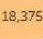
HP Dèśigńjót.T52O Tnkjet-
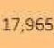
GBCDocuBind P40ó
Electric:Bindíñğ System
HIghSpeed Aútom'atic Electric Litter Ôp'ener


Steps

Step 2: Line Chart

Shows the sales trend over time using order date. Helps analyze how sales change across different periods.

Columns: Order Date
Rows: SUM(Sales)

Department of Data Science 12

File ¿Data Worksheet Dashboard Story Anztly sis Map Formztt Server Window .Help.
.Show' Me

Data AnalytlcB * Paj2ed
III Cclurnris
M M NT 0 e D

Tabie s
Abn C8t9g0t/ @ Eity
@ COLllltry Ate Customer IÔ
Abe Customer Name
B Oder Dat+ A , Order.ID @ Pcstal.Codé abe Product ID
nõo Product Narrie

áçc S'egment E] Ship Date Aün. Ship Mede
@ State
Abe Sub-Jaregcry n6n heztsen• /Yarnes
4 Discoufit
# Ptofit

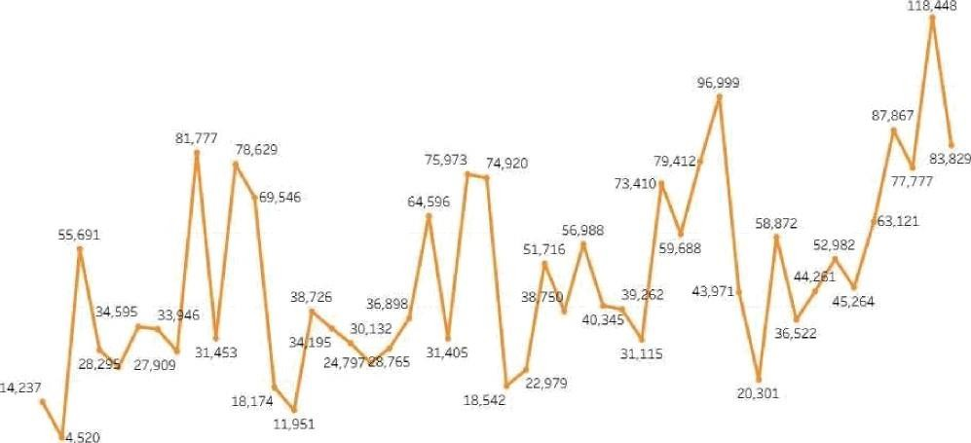
Sales Trand Óver Time

Month al Order Date

Data” Soúrce Tòp SetlingPiúd uúts'. :Safes Trend Over Time 'Category and:5ub-Ca legófy Sàl... .Diceo”únI ar\d P+òlil Relatiunship.„ Sàtes bj.CL Stòmer '2égmenI Profil'Óist'ributión Anàlysú @ E-Eümrf +=rèeNor,. ” @¿ @


Steps

Step 3: Heat Map

Represents the sales distribution across categories and sub-categories. Darker colors indicate higher sales values.

Columns: Category Rows: Sub-Category Color: SUM(Sales)

Department of Data Science 14

Tableau P bllc- Book1

File ¿Data Worksheet Dashboard Story Analysis Map Format Server Window .Help.
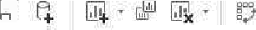
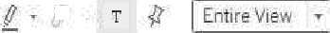
Data Analytics X f?at¡es

Tables
Abu Category
@ Cily
@ COLllltry
ca Customer ID Abu Customer Name B Dfder Date
u : 0rder.ID
@ Pusfal.Code lbc Product ID Abo Product Narrie lube Pegion

B Ship Date
/tbo: Ship Mcde
@ State
Abc Sub-(/atego y Adg VrarutWaMas
4 Discoufit

'.*.

Filters

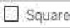

°y
. Rows 

Category and Sub Category Sales Analysis

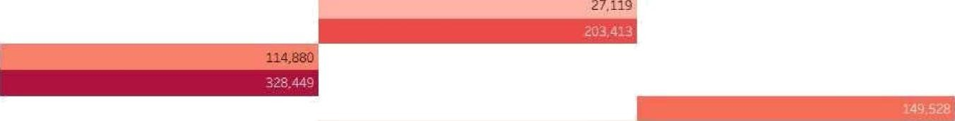
Sub—Cateqo.. Accessories Appllanies
Offich Supplies
Technology

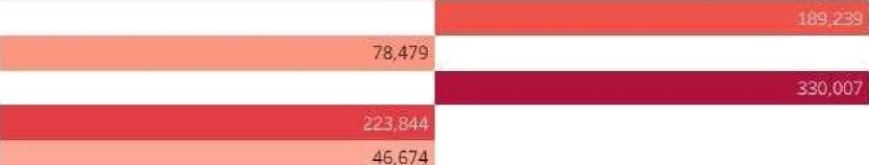
Binders Eiook”casas Chairs Copiers Enveiopes fiasteners fiumishi¿gs
Labels hñachines
Paper Phones Storage
Supplies Tables.

Category


Steps

Step 4: Scatter Plot

Shows the relationship between discount and profit.
Each circle represents sales records showing how discounts impact profit.

Columns: SUM(Discount)
Rows: SUM(Profit)
Color: Category

Department of Data Science 16

Tableau Public - Book1
Fi le ¿Data Worksheet Dashboard Story Analysis Map Format Server V¥indow .Help.
Data Analytics X I?ages

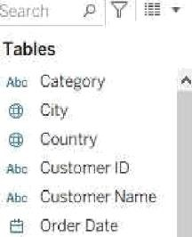
Idarhs

Discount and Profit Relationship Analysis

25,200

'?ajet zrv': Technology
Fi c duec ^.'awe! Canon imageCLASS ?Z00 Advancéd Copier

- 2
0 20.000
O 40:000”
@ 61.600

Abu. Order.ID
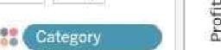

@ Postal.Eodé foe Product ID
Aoc Product Narrie.
D *'z ui .I!
r<uf i: !
>a:es:
D..60D

25,ZD0
61,600

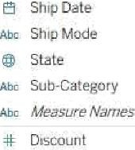

4 Salet

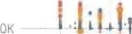


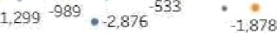
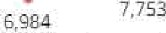
-5h.

-1 1iO
- 4.5713.345 2,518
@9 2 sis

-4.590’

1,179 e 2,234 329 761
.?.;.... .........i.,.. ....... ...g...
. -190 -Z4B. -sos -9 ’12 40 -2 3’ 44 S1’


Steps

Step 5: Stacked Bar Chart

Compares sales distribution across customer segments.
This helps understand which segment contributes the most to total sales.

Columns: Segment Rows: SUM(Sales) Color: Category

Department of Data Science 18

ï+¿| Tableau Püblic - Book1

File ¿Data Worksheet Dashboard Story Analysis Map Format Server V\/indow . Help.

Data AnalyticS X I?agea
III Culurriris

Tables
AôE CJtegory @ Eify
@ COurllry
xbc Cuatumer IÔ Aüc Customer Name B DrJer Date
abc. Order. ID
@ Pcsïal.Cudé
àcc Product ID
sec Product Narrie
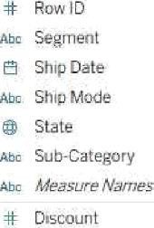

4 Salet

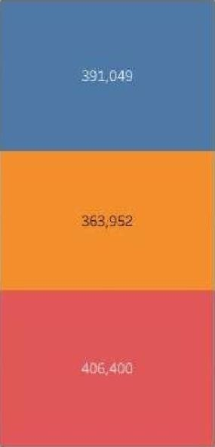
.*.


Sales by Customar Segment

Segment

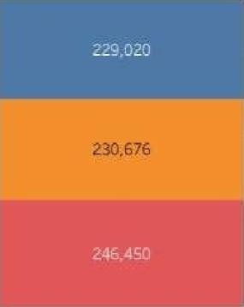
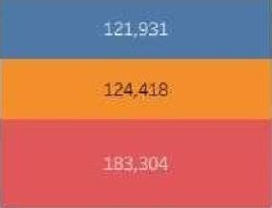



# Ttchrology

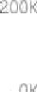
s rri l w by 3 ciiiOriins s un(sa iesJ. z,zs7.zOl


Steps

Step 6: Box-Whisker Plot

Displays the distribution of profit across product categories.
Useful for identifying profit variations and outliers.

Columns: Category
Rows: Profit

Department of Data Science 20

Tableau Püblic- Book1

File ¿Data Worksheet Dashğoard Story Analysiš Map Format ȚServer V¥rndow . Help.

Data AnalyticB Ś I?agea
İİİ Cclurriris

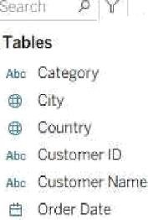
Abu. Order. ID
@ PcsŁal.Eodé
Doc Product ID
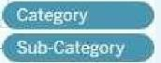
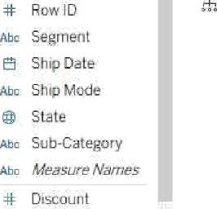
Aõç Product Narrie.
'Catëğò”ry
Sub-ûät”egõry

4ł Sales

kłarhs

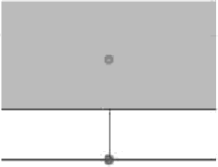
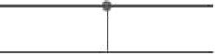
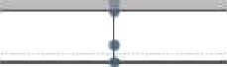
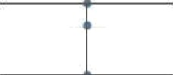
+•

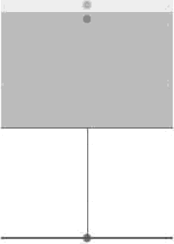
Profit Distribution AraIysi.s

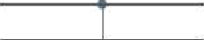


Dashboard

A dashboard combines all the visualizations to provide
a comprehensive view of consumer spending patterns. Filters such as Category, Segment, and Region allow users to interactively explore the data and analyze sales performance from different perspectives.

Department of Data Science 22

/| Tableau Pübllc - Book1
ȚFile ¿Data Worksheet Dashğoard Story Anałysiš Map Format Server Window .Herp,

DashbaatÓ Lńyout ¢

Default.
Phone

Òeviçe ł?review

Pr.odučt Name -
Canon iMageCL'ASS 2200..
Fèllowèś PÉ500 Electric P..

E-Commerce Consumers Spenoing Pa”tzern Analysis Dashboard

81,777 75,973

96.999 ”
79:412

11
87:867


17j
”Sa!+s

62k.

2

y 55,691
łJ0N 5400Series Task Ch..
7 , 20 Ü6,9G8 * 8 S8;872
3.121
¢' 20.DÓ0

Size
AułorñatiC

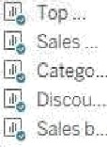
Sheets
EBC DocuBind TL3Q0Eînc:: ' GBC lbimaster.£ß0 Manna..: Hewlett Packard LaserJét.., HP Òèșignjet T52Q 1ùkjèt ..
HB B 'ndP
ghD d a0El Ele. ”

CateqöȚ
"" 2$,2 '”'’

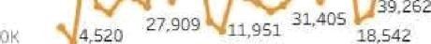
""
:,

##ZS.200

Month of Order Date

43”.971
ZÒ301

45.264. 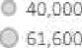
- -9 FÜfT›lU'm'.
Offic”e Su..
Technolo..

Objects

” Horizo ntaî Co... @ Ve2ica1.Có,rifai•,•
Å Text
@ Extension
PuIse Met«c @ lrriage”
Q Blom‹
SMb-CaEeğo.. Ačcessories Applian¢eS

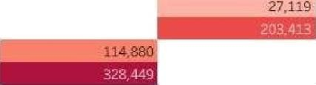
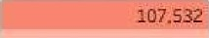
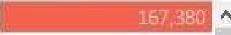
Brnderș Bookča'sés Waif.ș

Furniture
Œfice Supplies. Tșchnology

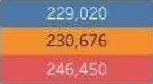

żÚK

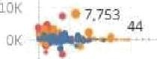
-lûK

40K

0 ž 4 ’’6
Oiscou œ
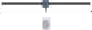
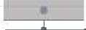
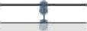
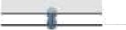
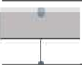

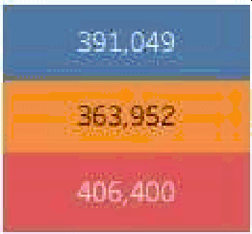
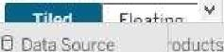
Sàleü bÿCüsfömer”Ségrńenf -Profit Dišt”fiõUtion áńâlÿśis g] E-Commerce Consumers S... ; .@ , ;


Conclusion
This project demonstrates how data visualization techniques can be used to analyze consumer spending behavior in an e-commerce environment.
Using Tableau, raw transactional data was transformed into meaningful visual insights. The analysis highlights important patterns in product sales, customer segments, and profitability.
Such insights can support businesses in making informed decisions regarding pricing strategies, product management, and marketing approaches.

Department of Data Science 24


STORY TELLING

A Story Behind Every Click
Story:
Meet Rahul, a 21-year-old college student.
One evening, Rahul opens his phone just to “check something” on an e-commerce app. Within minutes, he sees flash sales,
personalized recommendations, and “only 2 items left” notifications.
What started as casual browsing turns into multiple purchases —
a pair of headphones, a T-shirt, and a phone accessory.
Now imagine this happening not just with Rahul, but with millions of consumers every day.
- What makes people buy online?
- Why do some customers spend more than others?
- How do discounts, recommendations, and timing influence purchases?.
By analyzing consumer behavior, we can understand when, why, and how people spend money in e-commerce platforms.


Thank you !!

Department of Data Science 26

